Frozen Foods Provider

By

Navpreet kaur

Level-6

Final Project

Table of Contents

Project Proposal 3

Goals and Objectives 3

Project Scope 3

Project Specifications 3

Target Audience 3

Project Deliverables 4

Resource Requirements 4

Project Tasks and Milestones 4

Project Assumptions 5

Project Report 5

Detail Design 6

Home Page 6

Registration Page 6

Login Page 7

Food Admin View 7

Categories Admin View 8

All Food Categories Visitor View 8

All Food Visitor View 9

Order History Page Visitor View 9

Project Testing 10

User Manual 10

Summary 10

System Configuration 10

User Access Levels 10

# 

# 

# Project Proposal

## Goals and Objectives

The main goal or aim of the project is to implement an online web application named “Frozen Foods”. The main purpose of the application is help people to find frozen food product details and capable to place bulk order. In this application there are two types of users- admin and registered visitor. Admin has different functionalities as compare to registered visitor. Admin can add, edit, delete and check details of all food categories, food companies and food. Admin can also view the all-order history place on web application. Registered visitor is capable to place bulk order.

## Project Scope

The scope of this project is to implement an app named “Frozen Foods” with the help of which user can find any food details and place their bulk orders. The duration of the project is 20 working days which is equals to 4 weeks.

## Project Specifications

* Admin login/logout
* Add, edit, delete and check details of food categories, food companies and food details by admin.
* Admin can delete, edit and check bulk order history
* Admin can register new admins.
* Registered Visitor can login/logout.
* New Visitor can register.
* Visitor can place bulk order request of food according to their choice.

## Target Audience

The target audience for this project is the seeker who would like to interested in bulk order of frozen foods. The age can go from 20 plus to 60 plus.

## Project Deliverables

The deliverables of the project are:

|  |  |
| --- | --- |
| **Deliverable** | **Description** |
| Final Report | This will be the final report of the project. |
| Coding | The executable code of the project will go under this. |
| Documentation | This portrays the documentation of the project. |
| Testing | All the test details will be covered in this part. |

## Resource Requirements

* Windows Operating System.
* Microsoft word for documentation.
* Asp.net MVC Framework
* 64-bit Processor and 4 GB or more RAM
* Identity framework- ASP

## Project Tasks and Milestones

|  |  |  |  |  |
| --- | --- | --- | --- | --- |
| **Tasks** | **Week-1** | **Week-2** | **Week-3** | **Week-4** |
| Brainstorming and analysis |  |  |  |  |
| Planning and initial meeting Project Proposal document. |  |  |  |  |
| Database Design and UI Design |  |  |  |  |
| Identity framework implementation |  |  |  |  |
| Coding for admin and reporter |  |  |  |  |
| Testing |  |  |  |  |
| Final Documentation and closing |  |  |  |  |

## Project Assumptions

Following are the assumption made while implementing the project:

* One admin and registered visitor will be registered by default.
* Application will be free and open source.

# Project Report

#### Functional and Non-Functional

|  |  |
| --- | --- |
| Users | Functional |
| Admin | * Login/logout * Register new admins * Admin can add, edit, delete, check details for food categories, food companies and food details. * Admin can check details of bulk order history. |
| Customer | * Can view details of food categories, food companies and food entries. * Can place bulk order of frozen food. * New customers can register for free. * Login using valid credentials |
|  | Non- Functional |
|  | * High speed * Fast Loading time * High performance and security * All browsers compatibility. |

## Detail Design

### Home Page

The main landing page of the application. On navigation bar options are- Home, Food Companies, Food Categories, Register, Login.

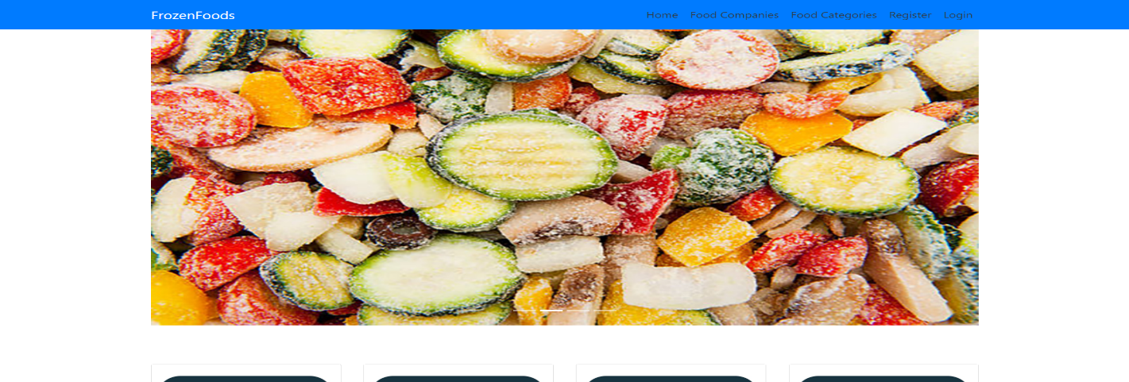

### Registration Page

With the help of this page, new registered visitor can sign up for the app

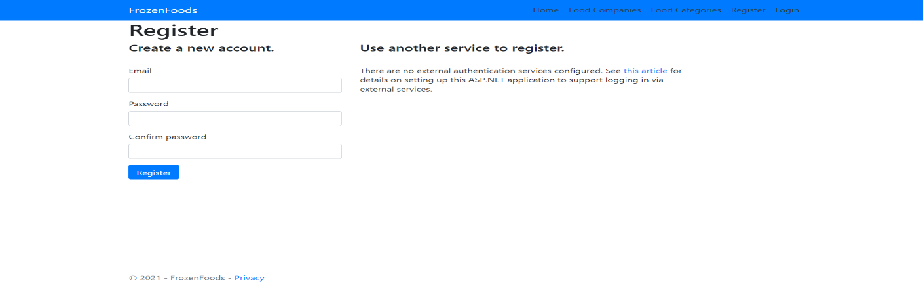

### 

### Login Page

With the help of this page, registered visitor and admin can login to the application using their valid credentials.

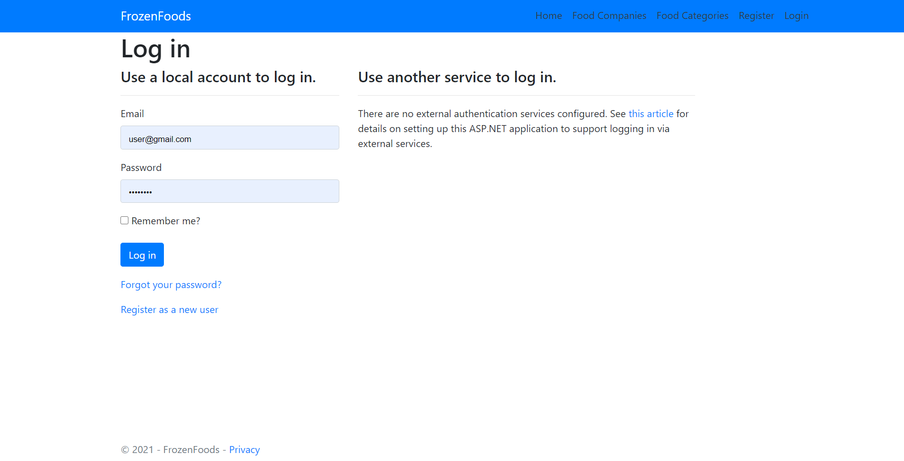

### Food Admin View

This page highlights all the Food details available on the application. Admin can add new Food Details, edit, delete and check details of the existing ones.

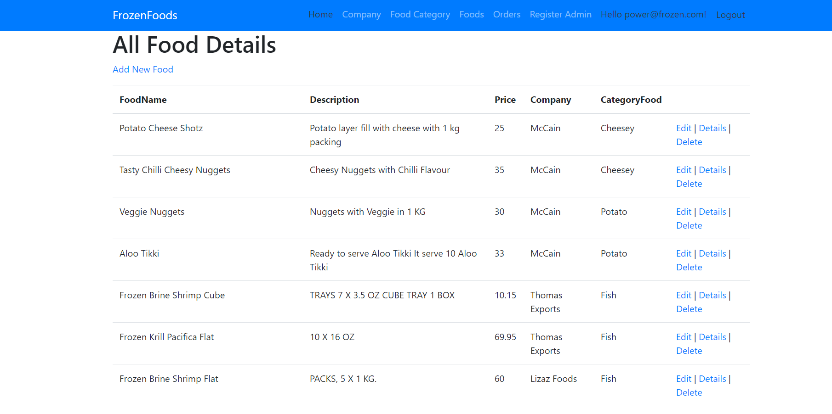

### Categories Admin View

With the help of this page admin can manage the Food Category details by editing, deleting and checking their details.

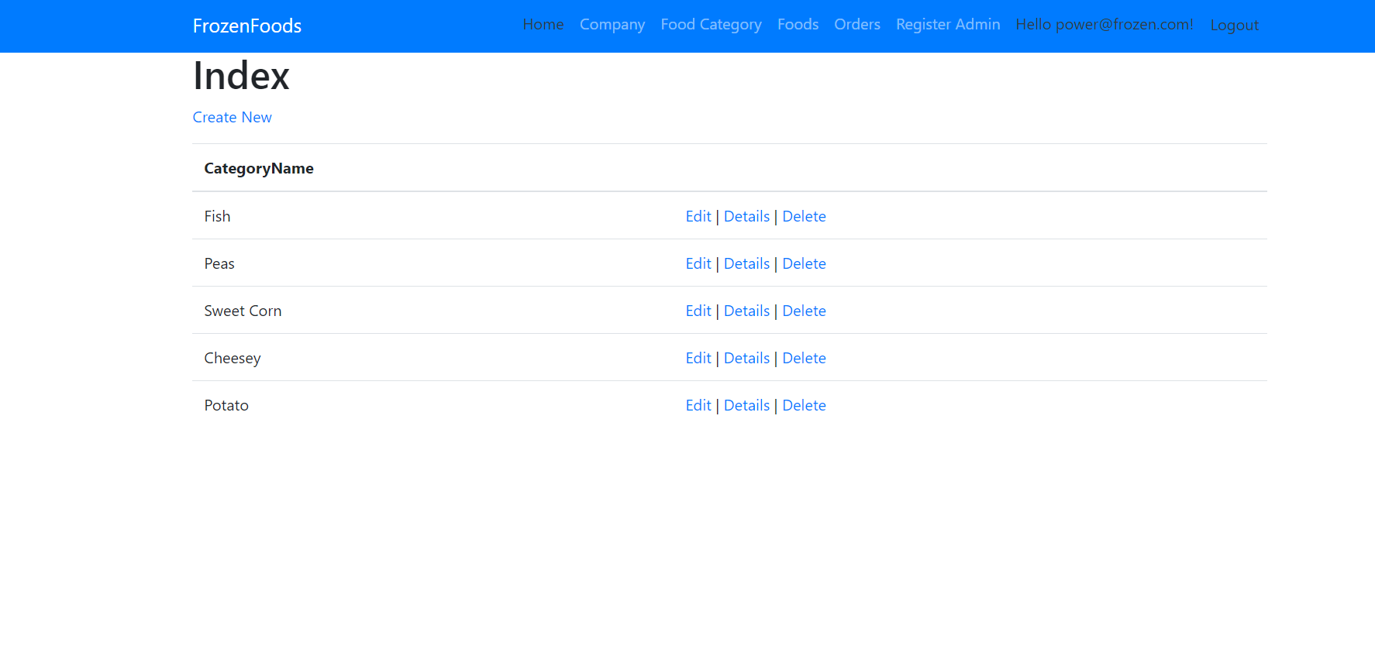

### All Food Categories Visitor View

With the help of this page Visitor can view All Food Categories details.

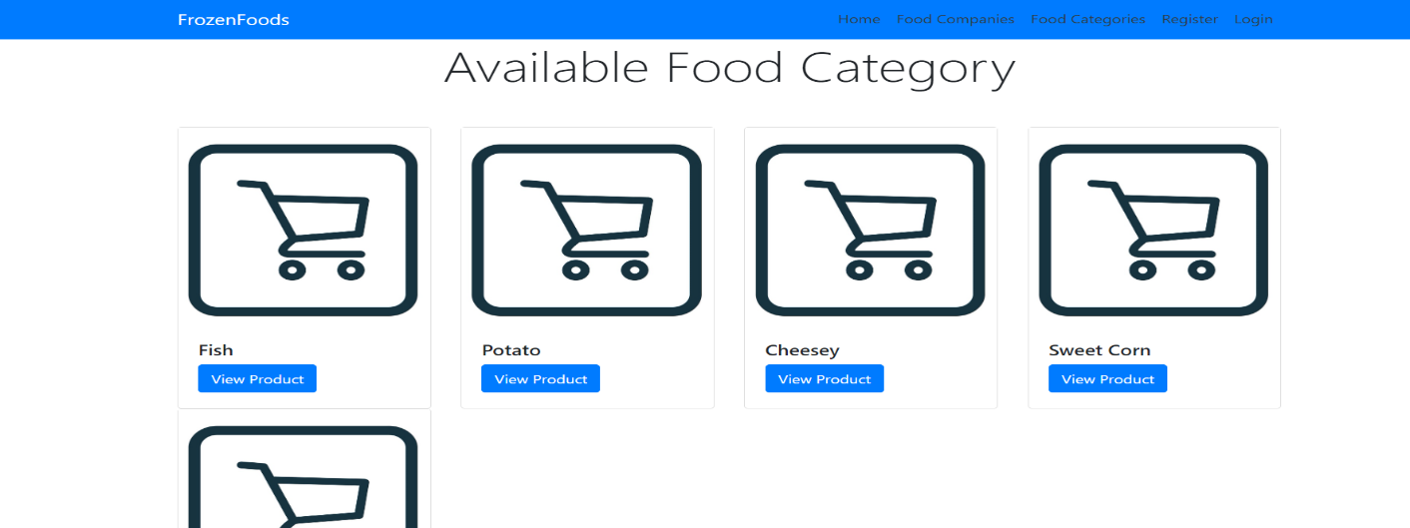

### All Food Visitor View

With the help of this page visitor can check the details of the Food Details.

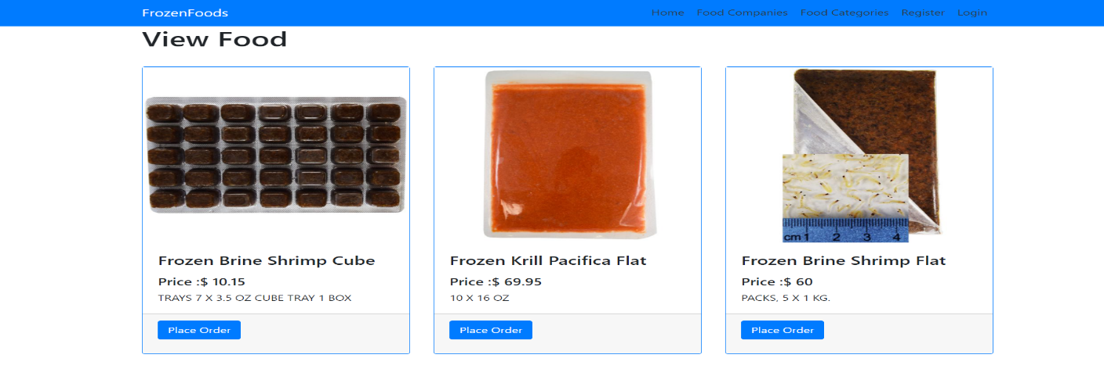

### Order History Page Customer View

This page shows the All Order History performed by a specific user

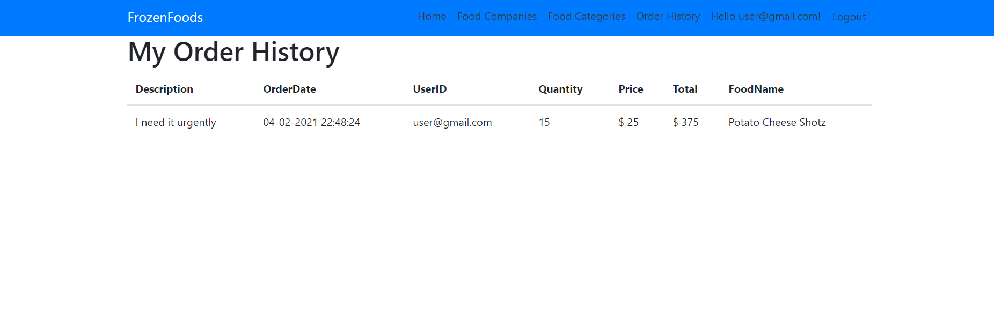

## 

## Project Testing

The testing file for usability testing is attached as [usability test.xlsx](usability%20test.xlsx)

# User Manual

The main purpose of the application Frozen Food is to help people to find frozen food of their choice based and they can also place a bulk order of frozen food according to their requirement. In this application there are two types of users- admin and registered user or visitor customer. Admin has different functionalities as compare to customers. Admin can add, edit, delete and check details of food categories, food companies and frozen food details. Also, registered user has authority to place bulk order.

## Summary

### System Configuration

This app will be useful to for providing an interface to showcase available food details and way to place a bulk order.

### User Access Levels

Only registered users can access the features of this application.

* **Admin:** Admin has full access of the app can register new admins.
* **Registered Visitor:** New visitor can register and existing can login using their own credentials. They have limited access.